**Registration Packet**

**For: __________________**





Dear LifePointe Parents,

We at LifePointe are honored that you have placed your trust in us to partner with you in your child’s development. Welcome to LifePointe Christian Academy!

In the next few pages

you will find the following topics:

Overview of LifePointe Christian Academy’s Curriculum: Pinnacle

Your Child’s Class Assignment

Tuition Rates and Fees

Holiday Calendar

School Supply List

*Registration Form A: Enrollment Information

*Registration Form B: Medical Authorization

*Registration Form C: Student Release Authorization

*Registration Form D: Tuition & Financial Agreement

*Registration Form E: General Consent Form

*Registration Form F: Discipline & Guidance Form

*Registration Form G: Getting to Know Your Child

*Facebook Photo/Video Release Form

*Infant Information Form: Required for ages 6 weeks to 17 months

* Infant Safe Sleep Form

*LCA’s Biting policies & Procedures

*Parent Handbook Agreement Form

*Health-Care Statement

Please go over the next few pages carefully and fill out the all forms and sign where needed. All forms and signatures returned no later than 48 hours prior to your child’s first day of attendance. We appreciate your cooperation and welcome any comments or concerns.

God Bless,

Kathi Klein

Director

LifePointe Christian Academy • [lcahutto@gmail.com](mailto:lcahutto@gmail.com) • (512) 846-2751



We are pleased to continue with our curriculum, The Pinnacle Curriculum a Faith-based Curriculum from Child Care Education Institute. This curriculum helps us ensure that every classroom is meeting the children's needs, abilities, and interests. It is based on the works of Piaget, Gardner, and Erikson, providing hands-on, center-based activities that promote the development of emerging skills. Written by early childhood experts with years of child care experience, Pinnacle Curriculum provides a research-based educational foundation for the children in our school. Teachers are exposed to early childhood development knowledge each day through Pinnacle Curriculum. The children delight in the fun, interactive activities that are available to them - they develop a love for learning while they are growing, playing, and having fun!

**Pinnacle Early Childhood Curriculum™** is designed to engage children in developmentally appropriate activities that move them toward their full potential. It provides teachers with daily information that makes creating meaningful learning experiences possible, without the time consuming research that lesson planning often takes.

**Infants and Toddlers** -- Pinnacle Curriculum for infants and toddlers provides activities that stimulate growth and development that can be incorporated into the routines of the day. Encouraging an atmosphere of caring, love, and hugs, Pinnacle Curriculum provides teachers with fun activities to do with little ones all day - even during the "Radical Routines" of eating and changing! Infant and toddler guides follow a weekly format, allowing teachers to choose several activities per day for each child. Lesson plans are designed for personalization, making it easy to craft the curriculum to meet each child's specific needs.

**Twos, Threes, and Fours** -- For two-, three-, and four-year-olds, Pinnacle Curriculum follows a daily activity format that matches the ever-changing needs of each rapidly developing child! Each age group has a separate curriculum that is specific to their educational and emotional needs, interests, and activity level. Pinnacle Curriculum provides for these age groups small and large group time activities, along with center-based activities. The activities in Pinnacle Curriculum meet learning objectives (Christian, social & interpersonal objectives, logical & mathematical objectives, language and emerging literacy objectives, gross motor skills, and fine motor skills) that will help each child move towards their full potential as they explore and experiment with materials and activities in the classroom.



**Curriculum**



Welcome! Your Child,

_________________________________________

Will be in the

**Navigator’s Class**: Infant Class

* + 6 weeks to 15 months

**Adventurer’s Class**: Young Toddler Class

* + 12 months to 24 months
  + **Discoverer’s Class**: Older Toddler Class
* 18 months to 36 months

**Seeker’s Class** or **Voyager’s Class**: 2 & 3 Year Old Classes

* + 2 years. old

**Pathfinder’s Class**: 3 & 4 Year Old Class

* 3 years. old

**Hiker’s Class**: Pre-Kindergarten Class – 4 year old classes

* + 4 & 5 years old

**Afterschool**: Afterschool Class – 6 year old classes

* + 6 years & older

Tuition Rates for your child’s new class will begin on September 1st. Please see the attached “Tuition & Fees.” If you have any questions, please come by the office and speak to a Director.

Thank You,

Kathi Klein

Director

LifePointe Christian Academy

lcahutto@gmail.com

(512) 846-2751

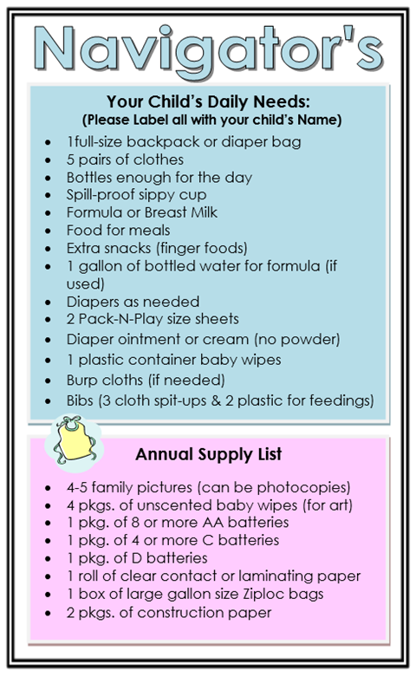



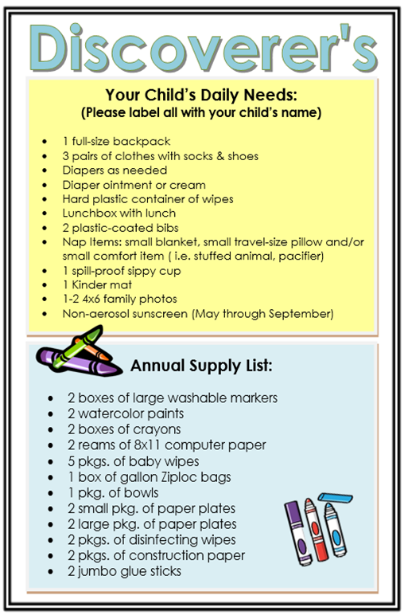

**Supply Lists**

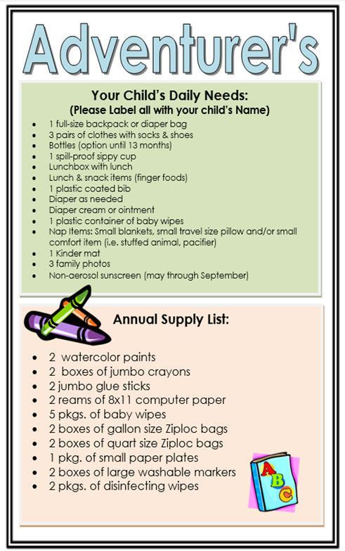



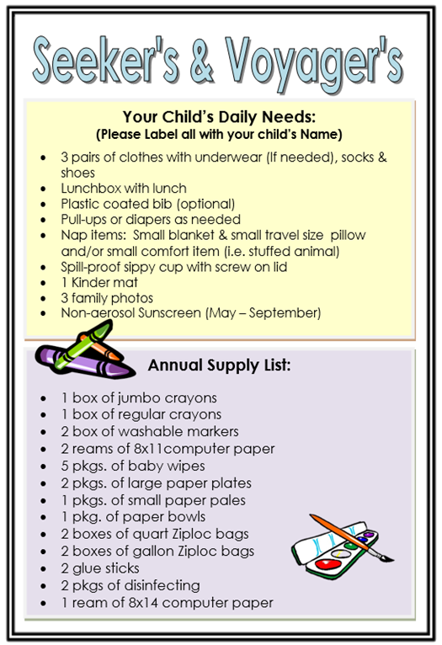



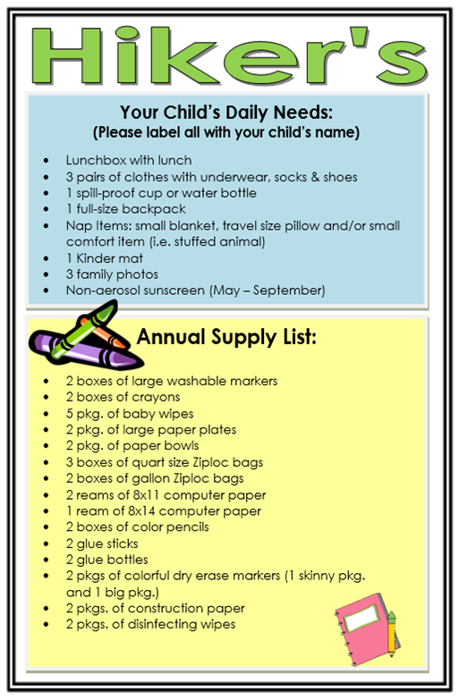

**Supply List**

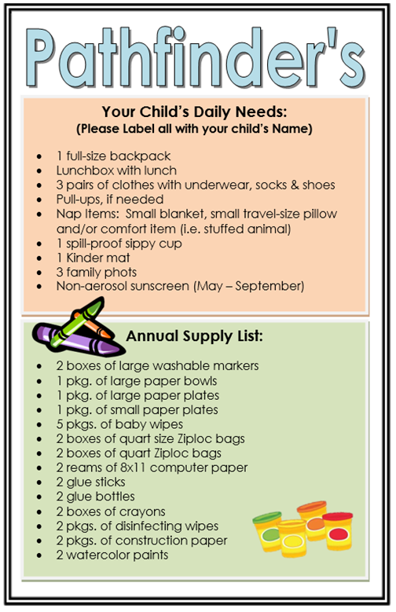





**Enrollment Information**

**Child’s Full Name**: _____________ ______________ ______________ Date of Birth:____/_____/_____

first name middle name last name

Date of Enrollment: ____/____/_______ Age at Time of Enrollment: year’s months

**Child’s Primary Residence Address**: ______________________________ ________________ __________

Street address city zip code

Child resides at the above address: Full-time On the following days: ________________________

Primary Phone number: _____________________ This is cell number of _________________________

Parent’s Marital Status: Married Single Separated Divorce Other: _______________

**Mother/Guardian’s Name**:_____________ ___ _____________________ Date of Birth:____/_____/____

first name initial last name

DL State: ___ #:___________ Address (if different child’s): ________________________________________

**Phone Numbers: (indicate which number you would prefer us to contact you by marking in boxes 1-3, 1 being best)**

**Cellular Number _( _____)_______________ Able to receive text messages Cellular Provider: ____________**

Home _( ) _____________ Work _( ) ________________ Other _( ) ____________

|  |  |  |  |  |  |  |  |  |  |  |  |  |  |  |  |  |  |  |  |  |  |  |  |  |  |  |  |  |  |  |  |  |  |
| --- | --- | --- | --- | --- | --- | --- | --- | --- | --- | --- | --- | --- | --- | --- | --- | --- | --- | --- | --- | --- | --- | --- | --- | --- | --- | --- | --- | --- | --- | --- | --- | --- | --- |
|  |  |  |  |  |  |  |  |  |  |  |  |  |  |  |  |  |  |  |  |  |  |  |  |  |  |  |  |  |  |  |  |  |  |

Email Address

Employer ________________________________ Address: ________________________________________

**Father/Guardian’s Name**:_____________ ___ _____________________ Date of Birth:____/_____/____

first name initial last name

DL State: ___ #:___________ Address (if different child’s): ________________________________________

**Phone Numbers: (indicate which number you would prefer us to contact you by marking in boxes 1-3, 1 being best)**

**Cellular Number _( _____)_______________ Able to receive text messages Cellular Provider: ____________**

Home _( ) _____________ Work _( ) ________________ Other _( ) ____________

|  |  |  |  |  |  |  |  |  |  |  |  |  |  |  |  |  |  |  |  |  |  |  |  |  |  |  |  |  |  |  |  |  |  |
| --- | --- | --- | --- | --- | --- | --- | --- | --- | --- | --- | --- | --- | --- | --- | --- | --- | --- | --- | --- | --- | --- | --- | --- | --- | --- | --- | --- | --- | --- | --- | --- | --- | --- |
|  |  |  |  |  |  |  |  |  |  |  |  |  |  |  |  |  |  |  |  |  |  |  |  |  |  |  |  |  |  |  |  |  |  |

Email Address

Employer ________________________________ Address: ________________________________________

I have provided court/legal documents that state the following persons cannot pick up the child.

1. ________________________ ____________ 2. _______________________ ____________

Name Relationship Name Relationship



**Medical Authorization**

At the time of an illness or accident that requires medical attention for a child and a parent, guardian or person listed as an emergency contact cannot be reached, a representative of LifePointe Christian Academy will either make arrangements for the transportation of a child to receive medical attention or will transport the child themselves. LifePointe Christian Academy has medical authorization to treat my child.

Parent’s/Guardian’s name: _______________________ Signature: ______________________ Date: ________

**Medical Provider & Insurance Information**

**Insurance:** _____________________________ ______________ ____________ _____________________

Company policy number Group ID name of person the policy is under

**Primary Doctor:** _____________________________________ Phone Number: ________________________

Doctor’s Address: ___________________________________________________________________________

**Primary Dentist:** _____________________________________ Phone Number: _______________________

Dentist’s Address: __________________________________________________________________________

**Preferred Hospital:** ___________________________________ Phone Number: ______________________

Hospital’s Address: _________________________________________________________________________

**Child’s Health**

**Allergies (please check the box next to an allergy in which immediate medical treatment is required):**

As of today ___/ ____/____My child has no known allergies Has the following allergies: Allergy: ___________________________ Reaction: ________________________________________

Treatment: __________________________________________________________________________ Allergy: ___________________________ Reaction: ________________________________________

Treatment: __________________________________________________________________________ Allergy: ___________________________ Reaction: ________________________________________

Treatment: __________________________________________________________________________ Allergy: ___________________________ Reaction: ________________________________________

Treatment: __________________________________________________________________________

**Special Needs:** List below any special challenges, learning disabilities, physical disabilities or health problems your child

may have so that we can help care for your child (i.e. bedwetting, biting, tubes in ears, chronic ear infections, existing

illness, previous serious illness, injuries and hospitalizations during the past 12 months, etc.).

___________________________________

**By signing this I state that the information contained in the Registration forms is true & accurate.**

Parent’s/Guardian’s name: _______________________ Signature: ______________________ Date: ________

Director’s/Representative’s name: _________________ Signature: ______________________ Date: ________



**Student Emergency Contacts & Release Form**

Child’s Name: __________________________________________ Date of Birth: ____________________

**In addition to his or her parents/guardians, the above named child will only be released to those persons**

**who are listed below**. The child will not be released to anyone not on the list and it is parents/guardians’

responsibility to update the list as necessary. In addition, a person on the “Student Release Form” meets the

following conditions:

* The person must be 18 years old or older
* The person must be able to present a valid photo ID (i.e. Driver’s License, Passport, State ID)
* The person’s name must match the name that is on their driver’s license or state ID

** EMERGENCY CONTACTS MUST INCLUDE PERSON’S PHYSICAL ADDRESS

Name: ________________________________ ID Number: __________________ Relationship to Child: ______________

Telephone Number: _(____)_______-_________ □ Cell □ Home □ Work _(____)_______-_________□ Cell □ Home □ Work

Address _________________________________________________ City __________________ Zip ____________

Can use as an emergency contact Do not use as emergency contact

Request to remove from list as of ____________ Signature _____________________________ (to remove)

Name: ________________________________ ID Number: __________________ Relationship to Child: ______________

Telephone Number: _(____)_______-_________ □ Cell □ Home □ Work _(____)_______-_________□ Cell □ Home □ Work

Address _________________________________________________ City __________________ Zip ____________

Can use as an emergency contact Do not use as emergency contact

Request to remove from list as of ____________ Signature _____________________________ (to remove)

Name: ________________________________ ID Number: __________________ Relationship to Child: ______________

Telephone Number: _(____)_______-_________ □ Cell □ Home □ Work _(____)_______-_________□ Cell □ Home □ Work

Address _________________________________________________ City __________________ Zip ____________

Can use as an emergency contact Do not use as emergency contact

Request to remove from list as of ____________ Signature _____________________________ (to remove)

Name: ________________________________ ID Number: __________________ Relationship to Child: ______________

Telephone Number: _(____)_______-_________ □ Cell □ Home □ Work _(____)_______-_________□ Cell □ Home □ Work

Address _________________________________________________ City __________________ Zip ____________

Can use as an emergency contact Do not use as emergency contact

Request to remove from list as of ____________ Signature _____________________________ (to remove)

Additional persons authorized to be an emergency contact and/or pick up are on the back of this form.





**Student Emergency Contacts & Release Form (Continued)**

Name: ________________________________ ID Number: __________________ Relationship to Child: ______________

Telephone Number: _(____)_______-_________ □ Cell □ Home □ Work _(____)_______-_________□ Cell □ Home □ Work

Address _________________________________________________ City __________________ Zip ____________

Can use as an emergency contact Do not use as emergency contact

Request to remove from list as of ____________ Signature _____________________________ (to remove)

Name: ________________________________ ID Number: __________________ Relationship to Child: ______________

Telephone Number: _(____)_______-_________ □ Cell □ Home □ Work _(____)_______-_________□ Cell □ Home □ Work

Address _________________________________________________ City __________________ Zip ____________

Can use as an emergency contact Do not use as emergency contact

Request to remove from list as of ____________ Signature _____________________________ (to remove)

Name: ________________________________ ID Number: __________________ Relationship to Child: ______________

Telephone Number: _(____)_______-_________ □ Cell □ Home □ Work _(____)_______-_________□ Cell □ Home □ Work

Address _________________________________________________ City __________________ Zip ____________

Can use as an emergency contact Do not use as emergency contact

Request to remove from list as of ____________ Signature _____________________________ (to remove)

Name: ________________________________ ID Number: __________________ Relationship to Child: ______________

Telephone Number: _(____)_______-_________ □ Cell □ Home □ Work _(____)_______-_________□ Cell □ Home □ Work

Address _________________________________________________ City __________________ Zip ____________

Can use as an emergency contact Do not use as emergency contact

Request to remove from list as of ____________ Signature _____________________________ (to remove)

*Texas DFPS Child Care “Licensing expects the parent to list someone other than themselves as an emergency contact and authorized to pick up their child from care.*

*Texas DFPS Child Care “Licensing expects the parent to list someone other than themselves as an emergency contact and authorized to pick up their child from care.*

Parent’s/Guardian’s name: _____________________ Signature: ________________________ Date: ________

Parent’s/Guardian’s name: _____________________ Signature: ________________________ Date: ________

Director’s Signature: _______________________________________ Date: ____________________________



TUITION & FINANCIAL

AGREEMENT - D

My child, ________________________________ on this day ______________ is enrolled in the following class:

Lil’ Navigators Adventurers Discoverers Voyagers

Seekers Pathfinders Hikers

**The above child’s schedule will be**:

2 Days a Week (T-Th) 3 Days a Week (M-W-F) Full-Time (5 days a week) Other: _____________

**The above child’s start date or date of this amended “Tuition or Payment Agreement” (due to a change in**

**payment plan, classroom assignment or schedule) will begin on the ______ of ___________________**

**The undersigned agrees to pay tuition and late fees calculated as follows:**

**Bi-monthly:** Due on the 1st and the 15 of each month will be in the amount of $__________________________

Tuition is due the1st and the 15th day of each month. Tuition is LATE if not received by the close of business on the 2nd or 16th day of the month. There is a one day grace period before a late fee will be applied to the account. The late fee will be due along with the tuition payment. Please see the chart below for Late Tuition Charges

**Monthly**: Due on the 1st of each month will be in the amount of $_____________________________________

Tuition is due the first day of each month. Tuition is LATE if not received by the close of business on the 2nd. There is a one day grace period before a late fee will be applied to the account. The late fee will be due along with the tuition payment. Please see the chart below for Late Tuition Charges

**My child receives funding through CCS**: $_____________________________________________________

The parent fee is stipulated by Texas Workforce CCMS and is due the first day of each month. Tuition is LATE if not received by the close of business on the 2nd. There is a one day grace period before a late fee will be applied to the account. The late fee will be due along with the tuition payment. Please see the chart below for Late Tuition Charges.

|  |  |
| --- | --- |
| **Late Tuition Charges** | |
| **Date Tuition Is Paid** | **Late Fees: To be paid along with the regular Tuition** |
| 1st & 15th of the Month | n/a |
| 2nd & 16th of the Month | $0 – Grace Period |
| 3rd & 17th of the Month | $10.00 |
| 4th & 18th of the Month | $15.00 |
| 5th & 19th of the Month | $20.00 |
| 6th & 20th of the Month | $25.00 |
| 7th & 21st of the Month | $30.00 |

**The Undersigned also agrees to pay the following fees when applicable:**

**Registration Fee** upon enrollment (non-refundable) in the amount of $_________________.

**ONE Week Deposit** upon enrollment (non-refundable) in the amount of $_________________.

**Annual Activity Fee** in the amount of $_________________.

**Kinder-mat Fee** (purchased through LCA) in the amount of $_________________.

**The undersigned understands and agrees to the above “Tuition & Financial payment” arrangements. Prior to changes in classroom assignment, age group, student’s schedule or payment plan, a new agreement must be filled out and signed.**

**By signing this “Tuition & Financial Agreement the undersigned understands and agrees to abide by the above “terms and conditions.”**

**Parent’s/Guardian’s name: _______________________ Signature: ______________________ Date: ________**

**Parent’s/Guardian’s name: _______________________ Signature: ______________________ Date: ________**

**Director’s/Representative’s name: _________________ Signature: ______________________ Date: ________**



**GETTING TO KNOW**

**YOUR CHILD - G**

Date:

**Child’s Name:** ____________________________________

**Nick Name:**  __________________ **Birth-Date:** ____________

**FAMILY**

**Please list who lives in the same household whith the child and their relationship and age.**

**Name Relationship Age**

1. **_________________________________ ______________________ ________**
2. **_________________________________ ______________________ ________**
3. **_________________________________ ______________________ ________**
4. **_________________________________ ______________________ ________**
5. **_________________________________ ______________________ ________**
6. **_________________________________ ______________________ ________**
7. **_________________________________ ______________________ ________**
8. **_________________________________ ______________________ ________**

**House-hold Pets:** ____________________________________________________________________

**Parent’s Marital Status:**

Married Single Together/not married Separated Divorce Other: _________

**Do any of the following people have little to no contact with your child?**

Father Mother Grandparents Other: ______________________________________

If yes, does your child have a significant role model in the place of one of the above persons?

Yes No. Please explain: _____________________________________________________

**Other family information you feel we should be aware of?** (i.e. protective orders, legal

Arrangements, foster home) _____________________________________________________

___________________________________________________________________________________

**Child Care & School Experience:**

Is this your child’s first experience in child care? Yes No. If No, what age did your child’s

first begin care outside the home? _______ What type of care was it? _________________

Your previous child care experience was Good Fair Concerning Poor

Other Comments: ______________________________________________________________

**Family Religious Affiliation & Faith**

What is your family’s religious denomination? ________________________________________

Does your family attend church? Yes No If yes, where? __________________________

**Your Child’s Health:**

Please check all that apply to your child and give details:

|  |  |  |  |
| --- | --- | --- | --- |
|  | Allergies to Food: |  | Seasonal Allergies |
|  | Allergies, other: |  | Lactose Intolerant |
|  | Asthma/receives regular breathing treatments |  | Speech Delay |
|  | Tonsillectomy |  | Vision or Glasses |
|  | Tubes in Ears |  | Hearing Loss |
|  | Hyperactivity |  | Diarrhea (frequent) |
|  | Sleeping Problems |  | Constipation (frequent) |
|  | Eczema or Skin Problems |  | Acid Reflux |
|  | Gluten Sensitivity |  | Clogged Tear Duck |
|  | Autism |  | Colic |
|  | Birth Defects |  | Born Premature |
|  | Hospitalization, please explain: | | |
|  | Other: Please explain: | | |
|  | Other: Please explain: | | |

Medications your child takes regularly: ______________________________________________

_____________________________________________________________________________

Side effects from medication: _____________________________________________________

**Toileting:**

Is your child Toilet trained? Yes No In the Process, please explain: ____________

_____________________________________________________________________________

At what age was the child completely toilet trained? ____________________________________

Does your child have occasional accidents? __________________________________________

Does the child need assistance with toileting? Yes No. If Yes, how? ________________

_____________________________________________________________________________

**Eating Preferences:**

Does your child self-feed? Yes No Eats with fingers? Yes No

Uses Utensils? Yes No Does your child choke easily while eating? Yes No

Child drinks from a bottle sippy-cup regular cup other: ________________

What are your child’s favorite foods? _______________________________________________

What foods does your child dislike? ________________________________________________

**Activities:**

What are your child’s favorite activities? What do they like to play? **________________________**

**_____________________________________________________________________________**

**_____________________________________________________________________________**

**Behavior:**

Does your child have any special fears?Yes No _______________________________

Does your child have a comfort item? Yes No _______________________________

List any special words your child uses that may not be readily recognized: _________________

____________________________________________________________________________

When your child gets upset what helps him/her calm down? ___________________________

Name any routines that help your child at nap-time? ___________________________________

How does your child respond when he/she is tired? ___________________________________

How does your child respond when he/she is hurt? ___________________________________

How does your child respond when he/she is angry? __________________________________

Other behaviors you would like us to know about? ____________________________________

____________________________________________________________________________

**Child Characteristics**

What 3 words best describe your child? **______________ ______________ ______________**

**Goals for this School Year**

What are your goals for your child this year? ________________________________________

____________________________________________________________________________

____________________________________________________________________________

____________________________________________________________________________

How can we assist your child and your family with the above goal? ______________________

_____________________________________________________________________________________________

_____________________________________________________________________________________________

**Preferred Method of Communication:**

If your child’s teacher needs to communicate information about your child’s day, concern or shortage of supplies, what is the preferred way to communicate? Email Phone Note Home

_______________________ _____________________ ______________________________

Name to contact Phone Number Email

Best Time to contact: ___________________________________________________________

**Signature of Guardian/Parent**

__________________________________ _________________ _________________________ _________

Printed Named of Guardian/Parent Relationship to Child Signature Date

**LifePointe Christian Academy Staff Review**

Director: ____________________________ Teacher: ___________________________________





**Tuition & Fees**

|  |  |
| --- | --- |
| Registration Fees (non-refundable) | |
| 1 Child | **$50** |
| 2 Children | **$75** |
| 3 or more Children | **$125** |

|  |  |
| --- | --- |
| Other Fees | |
| Nap Mat | **$30** |
| First Security Door Key Tag | **First included with registration fee** |
| Each Additional Security Door Key Tag | **$20** |

|  |
| --- |
| Tuition Deposit |
| A non-refundable deposit of two weeks tuition is due at the time of registration. This will be applied towards the first week of care provided for your child. |

|  |  |  |  |  |  |
| --- | --- | --- | --- | --- | --- |
| School Year Tuition | | | | | |
| Class | **Age of Child** | **Days** | **Monthly Tuition Plan** | **Bi-Monthly**  **(Due on the**  **1st & 15th)** | **Deposit** |
| Navigators | 6 weeks to 15 Mths. | **5 Days** | **$900** | **$460** | **$400** |
| Adventurers | **TODDLERS**  12 – 24 months | **5 Days** | **$760** | **$400** | **$180** |
| **3 Days** | **$530** | **$285** | **$125** |
| **2 Days** | **$405** | **$225** | **$85** |
| Discoverers | **TODDLERS**  18 – 36 mnths as of  September 1st | **5 Days** | **$725** | **$385** | **$165** |
| **3 Days** | **$530** | **$285** | **$115** |
| **2 Days** | **$405** | **$225** | **$80** |
| Seekers & Voyagers | **TWO YEAR OLDS**  **THREE YEAR OLDS**  2 as of  September 1 | **5 Days** | **$700** | **$370** | **$145** |
| **3 Days** | **$530** | **$285** | **$105** |
| **2 Days** | **$405** | **$225** | **$75** |
| Pathfinders | **3 YEAR OLDS**  3 as of  September 1 | **5 Days** | **$650** | **$345** | **$140** |
| **3 Days** | **$485** | **$285** | **$100** |
| **2 Days** | **$350** | **$195** | **$70** |
| Hikers | **PRE-KINDERGARTEN**  4 as of Sept. 1st | **5 Days** | **$650** | **$345** | **$140** |
| **3 Days** | **$485** | **$265** | **$100** |
| **2 Days** | **$350** | **$195** | **$70** |

Parent/Guardian Name ______________________________ Date__________________________

Parent/Guardian Name ______________________________ Date__________________________

Print

**Tuition is prorated to include all holidays and closures. No credit will be applied for closures, holidays or absences.

**Tuition is based on both students’ classroom assignment and meeting the above age group requirements.

**The above rates may change at any time. Enrolled families will be notified within 45 days of Tuition or Fee changes.

Signature

**Child’s Name** Date of Birth

**I give permission for my child to use any and all equipment on LifePointe Christian Academy’s**

**premises provided that the equipment is maintained and used properly according to the**

**manufacturers’ instructions, age and weight limits, and all safety and supervision precautions**

**are followed.**

Parent Date

**I give permission for photographs to be taken of my child in daily learning activities, holiday**

**or birthday parties and special events. Photographs will only be used and posted within LCA’s**

**building. Photographs will not be posted on any social media sight or website unless prior**

**written permission is given by parent/guardian.**

Parent Date

**Please place your initials on the products LCA staff may use on your child. Your child’s class will use a shared stock of certain supplies. If you want a specific brand used on your child, please supply a package with your child’s name clearly marked on it.**

Baby Wipes (used for hands & faces as well as diapering)

Diaper Rash Cream (only if in diapers or pull-ups/provided by the parents)

Chapstick or Lip Moisturizer (Optional and only if provided by the parents/guardians – must be given to child

care provider and not stored with belongings)

**________** Sunscreen (Required May through September) and/or Bug Spray-Provided by parent/guardians and labeled with child’s name

Must be given to child care provider and not stored with the child’s belongings) Both will be applied be a LCA staff member

Facial Tissues

Additional or Comments: ____________________________________________________________________________

____________________________________________________________________________________________________

____________________________________________________________________________________________________

Parent/Guardian Name Date ______

Parent/Guardian Name Date



GUIDANCE & DISCIPLINE FORM - F

**Discipline and Guidance Policy for LifePointe Christian Academy**

◆ Discipline must be:

(1) Individualized and consistent for each child;

(2) Appropriate to the child’s level of understanding; and

(3) Directed toward teaching the child acceptable behavior and self-control.

◆ A caregiver may only use positive methods of discipline and guidance that encourage

self-esteem, self-control, and self-direction, which include at least the following:

(1) Using praise and encouragement of good behavior instead of focusing only upon unacceptable behavior;

(2) Reminding a child of behavior expectations daily by using clear, positive statements;

(3) Redirecting behavior using positive statements; and

(4) Using brief supervised separation or time out from the group, when appropriate for the child’s age and development, which is limited to no more than one minute per year of the child’s age.

◆ There must be no harsh, cruel, or unusual treatment of any child. The following types of discipline and guidance are prohibited:

(1) Corporal punishment or threats of corporal punishment;

(2) Punishment associated with food, naps, or toilet training;

(3) Pinching, shaking, or biting a child;

(4) Hitting a child with a hand or instrument;

(5) Putting anything in or on a child’s mouth;

(6) Humiliating, ridiculing, rejecting, or yelling at a child;

(7) Subjecting a child to harsh, abusive, or profane language;

(8) Placing a child in a locked or dark room, bathroom, or closet with the door closed; and

(9) Requiring a child to remain silent or inactive for inappropriately long periods of time for the child’s age.

**Texas Administrative Code, Title 40, Chapters 746 and 747, Subchapters L, Discipline and Guidance**

**Minimum Standards for Child-Care Centers, Subchapter L, Discipline and Guidance, Chapter 746.2803 & 746.2805**

My signature verifies I have read and received a copy of this discipline and guidance policy.

______________________________ ________________________________ __________

Parent/Guardian Name Parent/Guardian Signature Date

Check one please:

🞎 parent 🞎 employee/caregiver 🞎 household member of child-care home



Facebook Photo/Video Release Form



Date

Parent or Guardian Name

Parent or Guardian Signature

Date

We have created a LifePointe Christian Academy Facebook page. The LCA page will provide a way to share school news, important information, special days/events, and photos of your little one(s) throughout the day. Please fill out the bottom portion, allowing LCA to post photos of your child(ren) on the LCA Facebook page. Families are more than welcome to visit and give our Facebook page “LifePointe Christian Academy” a thumbs up!

I would like photos of my child to be included on the LifePointe Christian Academy Facebook page with limitations such as, _____________________________________________

____________________________________________________

Name of child(ren)

**Please check which box applies to ___________________________**

I would like photos of my child to be included on the LifePointe Christian Academy Facebook page.

I would **NOT** like photos of my child to be included on the LifePointe Christian Academy Facebook page.



**INFANT INFORMATION**

**(6 WEEKS – 17 MONTHS)**

**This form must be updated every 30 days for all children who are 17 months & younger.**

Child’s name: ________________________________________________ Birth date: **___________________**

Parent’s names: Today’s Date: __________________

|  |  |
| --- | --- |
| **Time** | **Activity**  (nap, meal. etc.) |
| 7:00 AM |  |
| 7:30 AM |  |
| 8:00 AM |  |
| 8:30 AM |  |
| 9:00 AM |  |
| 9:30 AM |  |
| 10:00 AM |  |
| 10:30 AM |  |
| 11:00 AM |  |
| 11:30 AM |  |
| 12:00 PM |  |
| 12:30 PM |  |
| 1:00 PM |  |
| 1:30 PM |  |
| 2:00 PM |  |
| 2:30 PM |  |
| 3:00 PM |  |
| 3:30 PM |  |
| 4:00 PM |  |
| 4:30 PM |  |
| 5:00 PM |  |
| 5:30 PM |  |
| 6:00 PM |  |

**Allergies: _____________________________________________________**

**Special Needs: _______________________________________________**

**Bottle: Brand of Bottle _________________________________________**

**_____** Formula: Brand _________________________________________

_____ Breast Milk

_____ Heated _____ Room Temperature _____ Refrigerated

_____ How many ounces: _____ How Often: _________________

_____________________________________________________

**_____** Notes regarding feeding & schedule (strict scheduling, flexible, holds bottle, juice cup, etc.): __________________

_______________________________________________________

_______________________________________________________

**Solid Foods:**

_____ My child DOES NOT eat solid foods at this time.

_____ YES, my child eats solid foods,

_____ Age started solid foods: ____________________ Months Old

Type of Solids: _____ homemade _____ store bought,

_____ pureed _____ finger-foods _____ other: ___________

Other Notes (likes, dislikes, etc.): _________________________

________________________________________________________

Temperature: _____ Heated: _____ Room Temperature _____ Refrigerated, _____ Other: _________________________

Feeding techniques or special needs during feeding?

________________________________________________________________________________________________________________

**Soothing Techniques:**

**_____** Uses Pacifier - When: ___________________________________

_____ Sucks thumb – When: ___________________________________

_____ Other: _________________________________________________

**Nap Routine:**

How does your child fall asleep (rocking, patting, in crib, etc.)? ______________________________________________________________

Length of Naps: ________ Preferred Sleeping position: ___________

**Diapering Routine:**

_____ Wipes - Brand ___________________________________________

_____ Diaper Ointment – Brand: _______________________________

**Other Important Information about your Child**: _________________

___________________________________________________________________________________________________________________________________________________________________________________________

**Parent/Guardian Signature: Date:**

**Parent/Guardian Signature: Updated on:**



HEALTH-CARE

STATEMENT

**Must be filled out by a Medical**

**Health Care Professional**

*“Health status information is critical to ensuring that the individual needs of children are met, while protecting the health and safety of all children in care.”* Texas Department of Family and Protective Services

**Admission Requirement:**

A written statement, from a health-care professional who has examined the child within the past year (twelve months), indicating the child is able to take part in the childcare program. We have provided this form for your convenience or you can bring a health statement form from your child’s physician as long as it contains the following information: Child’s name, child’s birthdate, date child was last seen by the physician, physician’s name, medical facility’s address, medical facility’s phone number and physician’s signature.

|  |
| --- |
| Child’s Name: ______________________________________ Birthdate: _________________________ |
| HEALTH CARE PROFESSIONAL’S STATEMENT: I have examined the above named child within  the past year and find that he / she is able to take part in the day care program. |
| Name of health care professional: __________________________________________________  Address of health care professional: _________________________________________________  _______________________________________________________________________________ |
| Health Care Professional's Signature: _______________________________________________  Today’s Date: __________________________________________________________________ |

|  |
| --- |
| I have attached a separate Health-Statement from my child’s physician. It includes all of the above  information along with the physician’s signature and date.  Parent Signature: ________________________________ Date: ______________________ |

*LifePointe Christian Academy ● 1451 Carl Stern Drive, Hutto, Texas 78634 ● (512) 846-2751 ● lcahutto@gmail.com*



**Parent Handbook Agreement Form**

**Parent Handbook Policies Agreement**

I have received, read and understand the content, requirements, and expectations of the *LifePointe Christian Academy’s Parent Handbook*. I have received a copy of the policies and agree to abide by the policies and guidelines as a condition of my child’s enrollment at LifePointe Christian Academy. I understand that if I have questions, at any time, regarding the LCA Policies, I will consult one of the Directors.

**Please read the policy carefully to ensure that you understand the policy.**

Child’s Printed Name: ___________________________________________________________

Mother/Guardian’s Printed Name: _______________________________________________

Mother/Guardian’s Signature: ________________________________ Date: _____________

Father/Guardian’s Printed Name: ________________________________________________

Father/Guardian’s Signature: ________________________________ Date: _____________

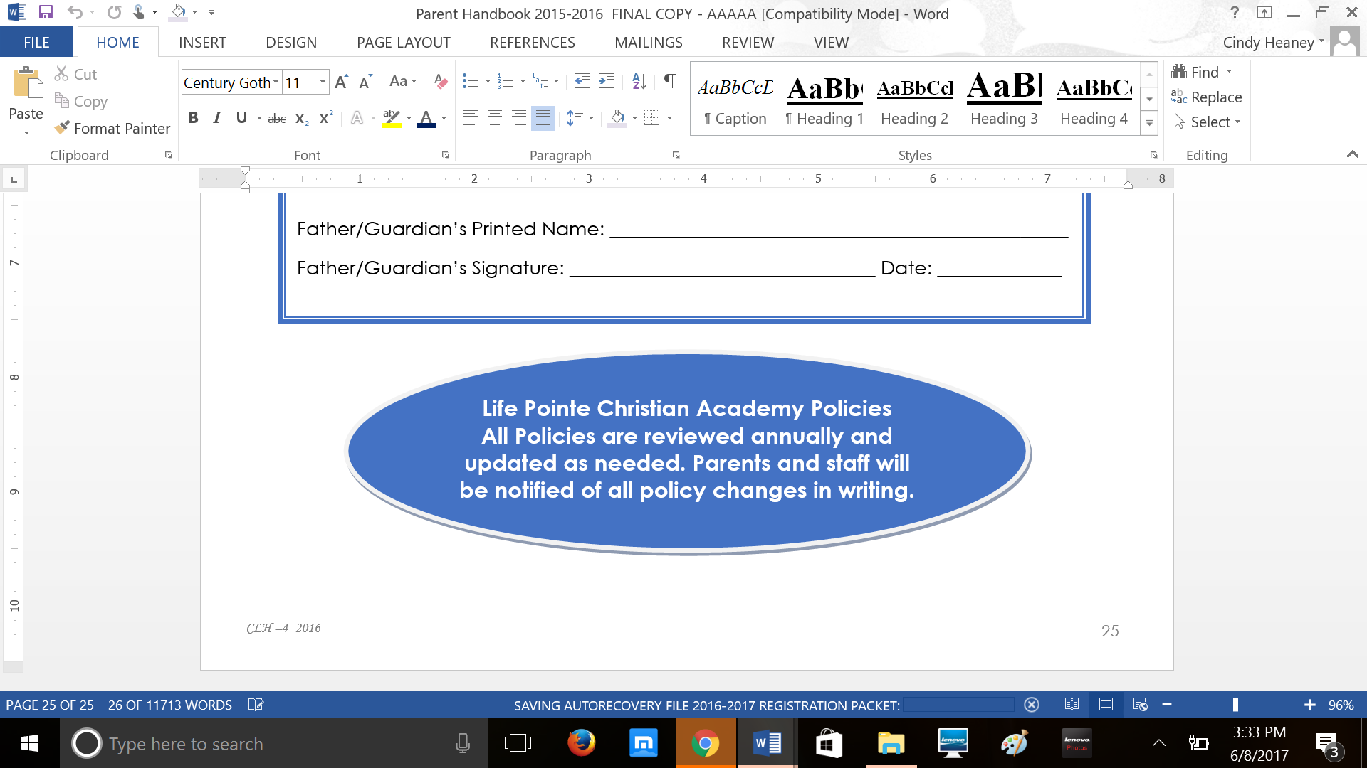

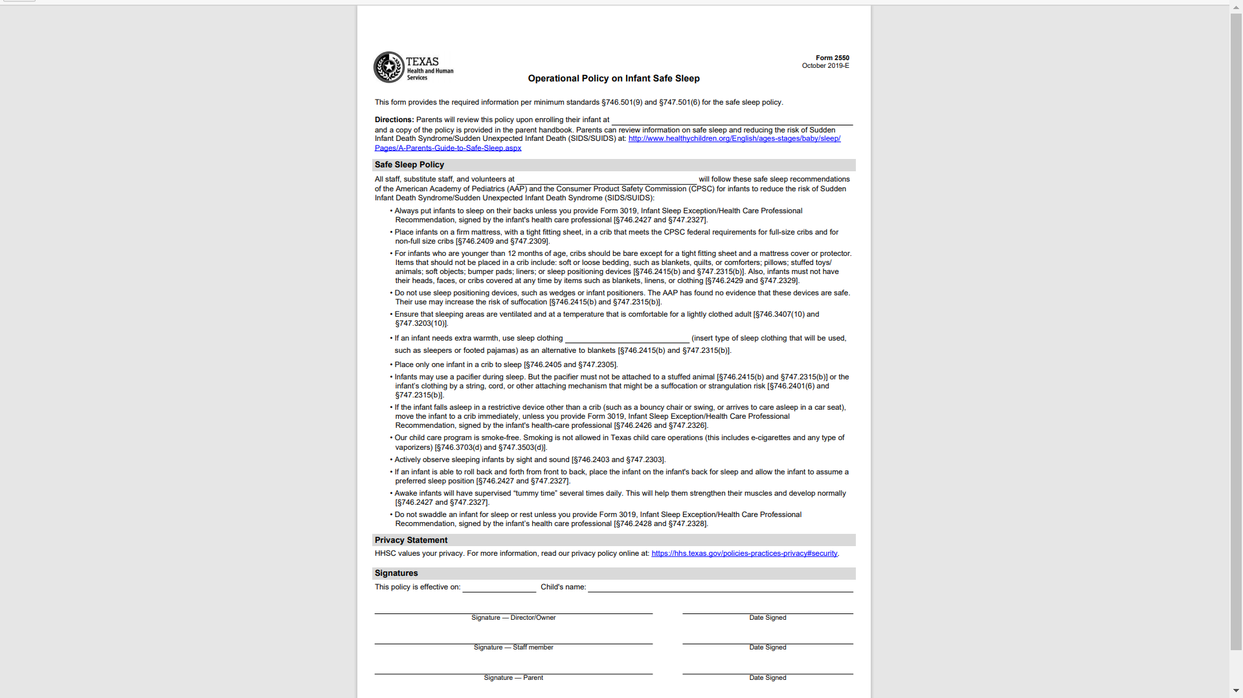

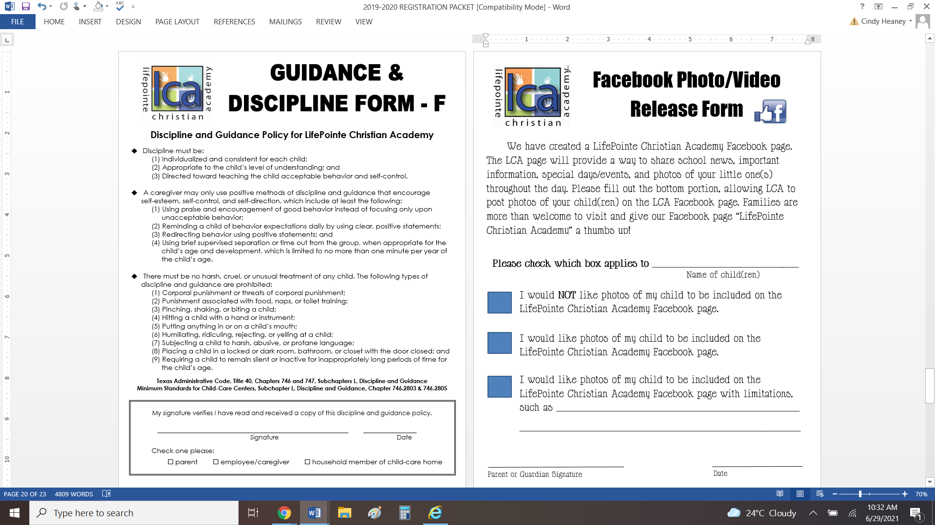

**PARENT COPY**



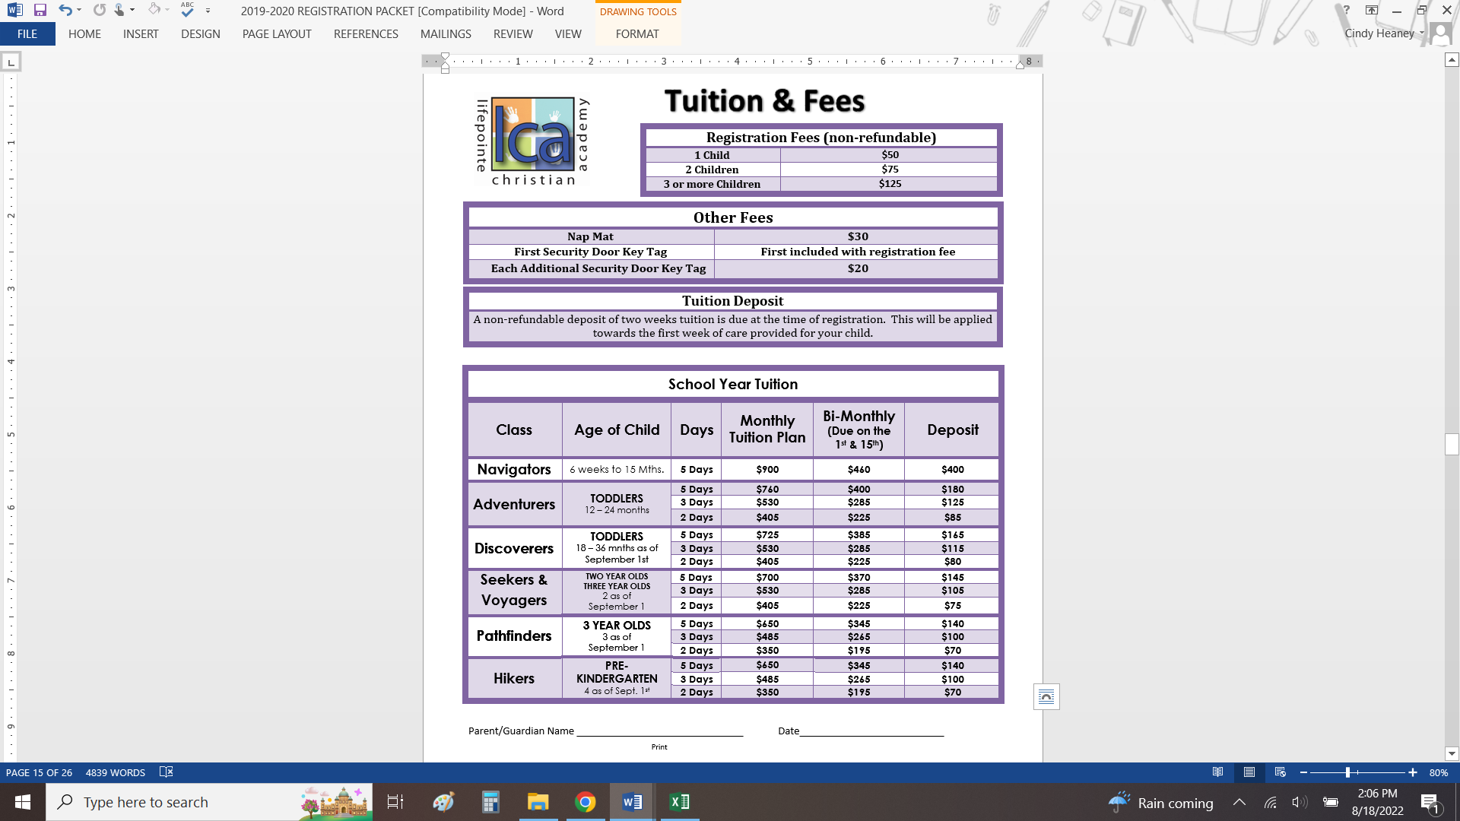

**\*\*Tuition is prorated to include all holidays and closures. No credit will be applied for closures, holidays or absences.**

**\*\*Tuition is based on both students’ classroom assignment and meeting the above age group requirements.**

**\*\*The above rates may change at any time. Enrolled families will be notified within 45 days of Tuition or Fee changes.**



**2022-2023**

**Holiday Calendar**

|  |  |  |  |
| --- | --- | --- | --- |
| **Year** | **Date** | **Day** | **Closed For** |
| **2022** | **August 12th** | **Friday** | **Staff Development Day** |
| **September 5th** | **Monday** | **Labor Day** |
| **November**  **23rd – 25th** | **Wednesday**  **Thursday**  **Friday** | **Thanksgiving Holiday** |
| **December**  **26th - 30th** | **Monday**  **Tuesday**  **Wednesday**  **Thursday**  **Friday** | **Christmas Holiday** |
| **2023**  Tuition is prorated to include the above holidays & vacations and will not be reduced for the weeks that include a holiday or vacation. | **January 2nd** | **Monday** | **New Year’s Eve** |
| **January 16th** | **Monday** | **MLK Day**  **(Staff Development Day)** |
| **February 20th** | **Monday** | **President’s Day**  **(Staff Development Day)** |
| **April 7th** | **Friday** | **Good Friday** |
| **May 29th** | **Monday** | **Memorial Day** |
| **June 19th** | **Monday** | **Juneteenth** |
| **July 4th** | **Tuesday** | **Fourth Of July** |
| **August TBD** | **TBD** | **Staff-Development Day** |

**Tuition is prorated to include the above holidays & vacations and will not be reduced for the weeks that include a holiday or vacation.**



CHILDREN ARE A GIFT FROM GOD; THEY ARE HIS REWARD

PSALM 127:3